Pokhara University

Level: Bachelor | Semester – Spring | Year : 2007
Programme: BE |  | Full Marks: 100
Course: Electronic Circuits I |  | Time : 3hrs.

Candidates are required to give their answers in their own words as far as practicable.
The figures in the margin indicate full marks.

Attempt all the questions.

 | - What is a multistage amplifier circuit? What are the various coupling schemes of two stages of amplifiers?  - Calculate the output Voltage for the given BJT amplifier. “This circuit is also called Emitter follower” Do you agree or disagree?. Justify your answer.  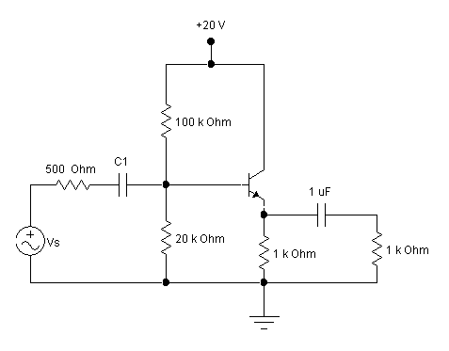  Assume : β =90, re= 15 Ohm, Vs = 1mV rms | 2+6  7
 | - Draw gain versus frequency plot for a BJT amplifier. Define Lower cut off frequency, Upper cut off frequency and Bandwidth. Explain why gain is low above upper cut off frequency.  - For the circuit given below, find the value of lower cut off frequency?  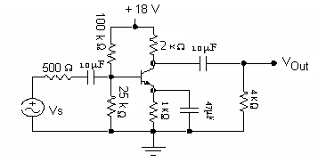  - Draw Complementary Symmetry Class B Push Pull amplifier and discuss its working principle. What is cross over distortion? | 5  5  5
 | - The Class A- amplifier shown in figure is biased at V_{CE} = 10 V. The output voltage is the maximum possible without distortion.  Find  - The average Power from the supply  - The average power delivered to the load  - The efficiency  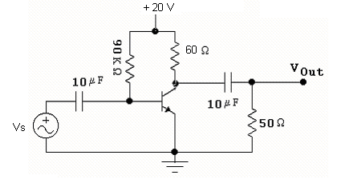  Assume β = 100, re = 25 ohm.  - What are the main advantages of Negative Feedback? Verify any one of them.  - An amplifier with voltage gain of 50 dB uses 1/ 10 of its output in negative feedback. Calculate the gain with feedback in dB. | 5  5  5
 | - What are the conditions for oscillation? How these conditions are used to derive the expression of frequency of oscillation in RC phase shift oscillator? Explain. .  - In ac. Equivalent of crystal we have L= 2 H, C = 0.02 pF, R = 10 Ω, and mounting capacitance Cm = 10 pF, find series resonant frequency and parallel resonant frequency. | 2+8  5
 | - What are the main characteristics of an ideal operational amplifier? Draw an integrator circuit and derive its output expression.  - How Operational Amplifier can be applied in comparators? Discuss with the help of necessary circuit and waveforms.  OR  b) Draw Monostable Multivibrator circuit and explain its operation. | 4+4  7  7
 | - Draw R-2R ladder Digital to Analog Converter and explain its operation. How it minimizes the drawbacks of binary weighted resistor DAC? Explain.  - Draw successive approximation type ADC and explain its operation.  OR  - “Transistors are connected in CE Configuration in intermediate stages while cascading” Do you agree or disagree?”. Justify your answer.  - “Bypass Capacitor reduces the voltage gain of Self Bias BJT amplifier at low frequencies” Do you agree or disagree?.” Justify your answer.  - Discuss various types of filters used in Regulated power supply. | 8  7  5  5  5
 | Write short notes on (Any Two):  - Power Dissipation and heat sinks.  - Ripple factor of Full Wave and half wave rectifiers  - Switched Mode Voltage regulator | 2×5

